**AUTOMATED TESTCASE GENERATION**

**Enrollment Numbers - 17103355, 17103350, 17103334**

**Names - Rishabh Kejariwal, Tanmay Agrawal, Abhishek Srivastava**

**Supervisor - Mrs. Deepti Singh**



**Dec - 2020**

**Submitted in partial fulfillment of the Degree of**

**Bachelors of Technology**

**in**

**Computer Science Engineering**

**DEPARTMENT OF COMPUTER SCIENCE ENGINEERING & INFORMATION TECHNOLOGY**

**JAYPEE INSTITUTE OF INFORMATION TECHNOLOGY, NOIDA**

**TABLE OF CONTENTS**

**(I)**

**Chapter No. Topics Page No.**

**Chapter - 1 Introduction** 9 – 10

1.1 Problem Statement 9 1.2 Language/Framework used 9

1.3 Project Repository Link 9

1.4 Problem Significance 10 1.5 Comparison of existing approaches 10

1.6 Brief Description of Solution Approach 10

**Chapter - 2 Literature Review** 11 - 20

2.1 Summary of Each Paper

**Chapter - 3 Requriment Analysis and Solution Approach** 21 - 21

3.1 Overall description of the project 21

3.2 Requirement Analysis 21

3.3 Proposed Approach 21

**Chapter – 4 Modelling and Implementation Details** 22 - 27

4.1 Database Schema Diagram 22

4.2 ER Diagram 23

4.3 Flowchart 24 4.4 Implementation Details 25 - 27

**Chapter - 5 Testing and Results** 27 - 29

5.1 Testing 27 5.2 Sample Testcases 27

5.3 Results 28

5.5 Screenshots 28-29

**Chapter - 6 Conclusion** 30 - 30

6.1 Conclusion 30

6.2 Future Work 30

**Chapter - 7 References**  31 - 32

–

**DECLARATION**

(II)

We hereby declare that this submission is our own work and that, to the best of our knowledge and belief, it contains no material previously published or written by another person nor material which has been accepted for the award of any other degree or diploma of the university or other institute of higher learning, except where due acknowledgment has been made in the text.

**Date**: 2 December 2020

**Name**: Rishabh Kejariwal, Tanmay Agrawal, Abhishek Srivastava

**Enrollment** **No**: 17103355, 17103350, 17103334

**CERTIFICATE**

(III)

This is to certify that the work titled “**AUTOMATED TESTCASE GENERATION**” submitted by “**Rishabh Kejariwal, Tanmay Agrawal, Abhishek Srivastava**” in partial fulfillment for the award of degree of Bachelors of Technology of Jaypee Institute of Information Technology, Noida has been carried out under my supervision. This work has not been submitted partially or wholly to any other University or Institute for the award of this or any other degree or diploma.

Signature of Supervisor:

Name of Supervisor: Mrs. Deepti Singh

Designation: Assistant Professor

Date: 2 December 2020

**ACKNOWLEDGEMENT**

(IV)

Signature of Students: Rishabh Kejariwal

Tanmay Agrawal

Abhishek Srivastava

Name of Students: Rishabh Kejariwal, Tanmay Agrawal, Abhishek Srivastava

Enrollment No: 17103355, 17103350, 17103334

Date: 2 December 2020

**Summary**

(V)

Testing is generally done on programming and additionally in web for testing customer and server engineering. Program testing is one of the major and essential procedures for accomplishing high quality software. Testing is accomplished to identify nearness of faults, which cause programming failures.

However, programming testing is a tedious and costly task. It expends practically half of the product frame work assets required for system development. Programming testing can likewise be characterized as procedure of confirming and validating program software to guarantee that product meets the specialized and in addition business necessities as expected in terms of technology.

Software testing is a major portion of software development process, so inspired by this thought we are trying to create a website where user can come and interact with the website and the website will help them to create testcases for their programming problems.

Like user can come and request testcases for graph or and array or a character array and side by side we are also giving them an api which they can use in their VSCODE to get the outputs for the inputs generated automatically.

Companies like **InterviewBit**, **Codechef**, **Codeforces**, **GeeksForGeeks**, **Atcoder** hire problem setters to create variety of programming problems for coding contest and their product library, the main issue faced here is the testcase generation.

We are trying to reduce this gap as to help the users to get the desired testcases in minutes.

This project can be a great help to above mentioned companies, also any user who is stuck on any coding problem can use this website to generate large testcases for the problem and test his/her solution with it.

Signature of Student

Name : Rishabh Kejariwal , Tanmay Agrawal, Abhishek Srivastava

Date : 02-12-2020

Signature of Supervisor

Name : Mrs. Deepti Singh

Date : 02-12-2020

(VI)

**LIST OF FIGURES**

|  |  |  |
| --- | --- | --- |
| **Figure No.** | **Figure Name** | **Page Number** |
| Fig 1 | Database Schema Diagram | 22 |
| Fig 2 | ER Diagram | 23 |
| Fig 3 | Flow Chart | 24 |
| Fig 4 | MVC Diagram | 25 |
| Fig 5 | Testcase Generation Form | 28 |
| Fig 6 | Problem Show Page | 28 |
| Fig 7 | Code Submission Page | 29 |
| Fig 8 | Problem show page after generating outputs | 29 |

**LIST OF ACRONYMS**

(VII)

|  |  |  |
| --- | --- | --- |
| **S. No.** | **Acronyms** | **Representation** |
| 1. | HTML | Hypertext Markup Language |
| 2. | CSS | Cascading Style Sheet |
| 3. | JS | JavaScript |
| 4. | ROR | Ruby on Rails |
| 5. | ER | Entity Relationship |
| 6. | CI | Continuous Integration |
| 7. | CD | Continuous Deployment |

**Problem Statement:**

To generate testcases on the server-side according to user preferences and then helping the user to generate the output files.

Software testing is a major portion of software development process, so inspired by this thought we created a website where user can come and interact with the website and the website will help them to create testcases for their programming problems and also create output files for the testcases they created by running the code on the website.

Like user can come and request testcases for graph or and array or a character array and side by side we are also giving them an option to get the outputs for the inputs generated automatically.

We are also using an API for an IDE to be put up on our website so that user can come and

Play around with their code.

**Languages/Framework Used:**

1. **Front-end:**

   

1. **Back-end:**



**Tools Used:**

   

**Project Repository Link:**

<https://github.com/awpCode/MajorProject>

**Problem Significance:**

E-Learning is learning utilizing electronic technologies to access educational curriculum outside of a traditional classroom.  In most cases, it refers to a course, program or degree delivered completely online.

**For example:**

Consider companies like Codechef, GeeksForGeeks, InterviewBit, Codeforces help their users to practice competitive programming and also them to prepare for the interviews.

Major part of the brain storming is done by solving DSA Problems on their website, motivated by the problem’s users try to innovate and think of a new problem which they can create but they get stuck when it comes to testcase generation, we know this because we have worked as Problem Setters in those companies.

So, this project will mainly help those companies and those users to create testcases as of their choice in second also the site will help them to generate outputs on the server itself.

**Comparison of existing approaches to the problem framed:**

Their exist sites to generate testcases but they only help users to generate a single type of input in each testcases but we are providing users to generate multiple type of inputs in a single testcase files as DSA based programming question nowadays relies on multiple type of inputs.

**Brief Description of the Solution Approach**

First of all, users need to pass through an authentication system to visit the website then they have option to retrieve or edit the older testcases they formed or to create a new problem.

We are putting up a form in front of users to ask for the testcase description , after they submit the form we run a RUBY script on our server to generate the outputs and then we are saving them on the database after that if users wants to get the outputs too then we are showing a prompt first to let the user give us the code on which he/she wants to run the testcases, after this we are sending an HTTP request to an API which generates and return the output file for each input file.

Apart from this we are also providing user with an Online IDE which they can use to play around with their code.

**LITERATURE SURVEY:**

1. **Comparative study on test case generation [1]**

In this paper, applications of Genetic Algorithm in different types of program testing is discussed. It is found that by using Genetic Algorithm, the performance and the outcomes of testing can be highly improved.

Firstly, they generate test case generation using model-based testing, random based testing, genetic algorithm and test scenarios from the activity diagram and then for each scenario the corresponding sequence diagram should be generated. After analysing and investigating each category, its critical values and constraints are produced and particular test cases are determined. Test coverage criteria achieved is another advantage of their approach.

1. **Automatic Software Test Case Generation [2]**

Software testing is the process of executing a program in order to find faults. Testing is a very important, though expensive phase in software development and maintenance; it has been estimated that software testing entails between 30 percent and 50 percent of software development [1].

A challenging part of this phase entails the generation of test cases. This generation is crucial to the success of the test because it is impossible to achieve a fully tested program given that the number of test cases needed for fully testing a software program is infinite, and a suitable design of test cases will be able to detect a great number of faults. For these reasons, the techniques for automatic generation of test cases try to efficiently find a small set of cases that allow an adequacy criterion to be fulfilled, thus reducing the cost of software testing and resulting in more efficient testing of software products.

A test case is a set of tests performed in a sequence and related to a test objective, which will produce a number of tests comprising specific input values, observed output, expected output, and any other information needed for the test to run, such as environment prerequisites [2].

In this paper we represented two different classification frameworks for the existing automatic test case generation approaches, and also have a brief look at each one. We described how to evaluate generated test cases, and introduce a classification of evaluation approaches. The results show that different approaches should be selected based on types of applications, features of software we want to test, technique’s complexity, and other features. Although there have been lots of researches on automatic test case generation problem, but for real world systems more researches are still needed.

# Content Management in Ruby on Rails [3]

Web development is currently driven by model-view-controller (MVC) frameworks. How has content management adapted to this scenario? This paper reviews content management features in Ruby on Rails framework and its most popular plug-ins. These features are distributed among the different layers of the MVC architecture.

How has content management adapted to the arrival of web development frameworks? Using frameworks for web development has become a common practice. Model-view-controller (MVC) patterns facilitate development. They hide complexity, give structure and consistence and promote best practices. Their code is better tested. Finally, a framework becomes popular if it has something useful to offer.

# Content management features keep up with Ruby on Rails development framework. Most of them are integrated in the framework itself, while others are distributed as plug-ins. However, some of them are more popular than others, even than the most popular full-featured content management solution. Content management features are transversal to the MVC architecture, they use some or even all the layers.

# New technologies for web development [4]

# The paper gives an overview of the new features of web technologies. The general idea of the new version of HTML (Hyper Text Mark-up Language), i.e. HTML5, and other tools presented in this paper is the formal specification and the establishment of uniform solutions for technologies and functionalities which have already been in use through various hacks and plug-ins proposed by web developers. Many of these functionalities will now be implemented in browsers. The applications can access these functionalities through newly defined application programming interfaces. The latter include support for multimedia, dynamic graphic rendering, geolocation, multithreading local data storage etc. HTML5 also introduces semantic mark-up, which can be used for marking the document structure as well as its elements and data. The new version of HTML enforces strict separation of the page content from its style. The styling can only be done using CSS (Cascading Style Sheets) language. The new CSS version, i.e. CSS3, has a modular structure, in which different modules define different styling features. The development cycles of the individual modules are independent as well as their support and implementation in various browsers. The general idea of HTML5 and other tools presented in this paper is the formal specification and the establishment of uniform solutions for technologies and functionalities which have already been in use through various hacks and plug-ins proposed by web developers.

1. **A Django Based Educational Resource Sharing Website [5]**

Technological Implementations in the field of Academics has helped Students as well as Professionals in very important ways. The availability of all educational resources helps the students a lot in their educational life. The paper illustrates a website model with the help of which Students can be able to access class notes, previous year question papers, syllabus, and can sell their old books from the same digital platform as well. The paper also describes the role of software engineering in project development. The project is developed on Django Framework; the backend development is in Python, Jinja2 and SQLite. The frontend consists of HTML, CSS and Java. Appropriate SDLC Model and Testing techniques have been used in the development process. Each step of the SDLC Model (Iterative Model) is described thoroughly and respective ER Diagrams and Flow Charts have been shown. The project developed is highly efficient, user-friendly and simple.

After analyzing the results obtained by the authors, the project developed can be considered satisfiable. It can be concluded that the website will be very helpful to students in their educational life as it provides all educational resources required in a college or school life. As the project works as an Educational cum E-Commerce Website and thus students can donate or sell their old books too.

1. **Agile Development using Ruby on Rails Framework [6]**

Since Ruby on rails was established in 2004, ruby on rails is speedily becoming a powerful and standard framework for building web application. Rails is a development tool which gives web developers framework, providing structure for all the code they write. The Rails framework helps developers to build websites and applications, because it abstracts and simplifies common repetitive tasks. One of key principles of Ruby on Rails development is convention over configuration. This means that the programmer does not have to spend a lot of time configuring files in order to get setup, Ruby on Rails comes with a set of conventions which help speed up development. In this research paper we included detail information about Ruby on Rails like advantages of Ruby on Rails, MVC Architecture of Rails, Rails Framework and component of Ruby on Rails. Then explained Agile in detail. In agile we explained Agile Approach in Ruby on Rails, Agile Web Development Process, and explained Agile Development Methodology in Ruby on Rails for developing application. Then researcher has explained the web application which is develop in Ruby on Rails this application is develop by researcher.

Ruby on Rails is an open source web application development framework focused on Ruby programming languages and used extensively by agile programmer team has been popular for rapid web application development. The interesting aspect of ROR is programmer specify unusual configuration and as well as information used is unique and not duplicate. Rails is a perfect platform for Agile development practices. Ruby on Rails is extraordinary framework for creating web applications writing very little code in comparison.

1. **On the Analysis of Cascading Style Sheets [7]**

Developing and maintaining cascading style sheets (CSS) is an important issue to web developers as they suffer from the lack of rigorous methods. Most existing means rely on validators that check syntactic rules, and on runtime debuggers that check the behaviour of a CSS style sheet on a particular document instance. However, the aim of most style sheets is to be applied to an entire set of documents, usually defined by some schema. To this end, a CSS style sheet is usually written w.r.t. a given schema. While usual debugging tools help reducing the number of bugs, they do not ultimately allow to prove properties over the whole set of documents to which the style sheet is intended to be applied.

In this paper authors propose a novel approach to fill this lack. They introduce ideas borrowed from the fields of logic and compile-time verification for the analysis of CSS style sheets. They present an original tool based on recent advances in tree logics. The tool is capable of statically detecting a wide range of errors (such as empty CSS selectors and semantically equivalent selectors), as well as proving properties related to sets of documents (such as coverage of styling information), in the presence or absence of schema information. This new tool can be used in addition to existing runtime debuggers to ensure a higher level of quality of CSS style sheets.in comparison.

1. **Responsive Web Design and Web Development Using Bootstrap Framework [8]**

Responsive Web design and Web Development which is aimed to provide design and development should respond to the user’s behavior and environment based on screen size, platform and orientation. A web design implementation consists of a mix of flexible grids and layouts, images and an intelligent use of HTML5 & CSS3 media queries. The web site layout changes based on the size and capabilities of the device. As the user switches from their laptop to Smartphone or any other such devices like iPad, iPhone, Tablet, etc., the website should automatically switch to provide accommodation for resolution, image size and scripting abilities. The website should have the technology to automatically respond to the user’s preferences. It is worth putting extra consideration that, this would remove the need for a different design and development phase for each new gadget on the market. Responsive web design (RWD) is a web design approach basically aimed at crafting sites to provide an optimal viewing experience. In this paper also discuss about twitter bootstrap and angularJS framework which is an important toolkit for responsive web development (such as easy reading and navigation with a minimum of resizing, panning, and scrolling — across a wide range of devices from desktop computer monitors to mobile phones).

Responsive Web Design is a rising trend that involves designing websites and applications for optimal presentation across multiple devices and screen sizes using a single code base. The major advantages of Responsive Web Design consist of a single code base that provides easy and low maintenance along with a distinct version of the website that improves SEO. Therefore, if you want a solution that’s easy to maintain, makes use of existing skills, framework or tool and that you can control, then Responsive Web Design is the approach for you.

1. **Website Development Optimization Using Xampp/PHP [9]**

This research paper discussing the various useful tools and techniques that are used in a development of a website. They also discuss about the procedure follow in a website, mostly focused on a local host named Xampp tool. Next, they compare different development frameworks web application. In addition, they discuss life cycle model and framework development of web application. In this report, various review papers result also included for understanding of problems can be facing by the users. This Paper tells about the technologies used in this development, PHP and explained in result its functionality with Xampp with screenshots. It is hoped it will give a useful framework for guiding the process.

Most necessary things for a website are selecting a programming language. Mostly web design using HTML and CSS. For web designing not necessarily high-level knowledge of HTML. We can say features like as webpage formatting, designing, page layout techniques, graphics, multimedia, images and functions of multipage website should be including. After programming language to see the layout of webpage should a test server. The reason behind is developer is using programming language, if will be the expert of language but still running often these mistakes cannot be found, there is a need to execute server-side coding to see the preview by a test server. This paper discussing about the test server using in a website development named Xampp and PHP language.

1. **A Review Paper on MERN Stack for Web Development [10]**

The stacks used in web development are basically the response of software engineers to current demands. They have essentially adopted preexisting frameworks (including JavaScript) to make their lives easier. While there are many, MEAN and MERN are just two of the popular stacks that have evolved out of JavaScript. Both of these stacks are made up of open source components and offer an end-to-end framework for building comprehensive web apps that enable browsers to connect with databases. The common theme between the two is JavaScript and this is also the key benefit of using either stack. You can basically avoid any syntax errors or any confusion by just coding in one programming language, JavaScript. Another advantage of building your next web project with MEAN or MERN is the fact that you benefit from its enhanced flexibility.

React gives you freedom and simplicity. We have to write less code to do more in React, also React has better performance than Angular due to React’s implementation of a virtual DOM. ReactJS can be used for both client and server side that means you have not to learn two language for server and client side. In React the changes in Application are easy to satisfy the client need. The paper has discussed about the use of mean stack for development along with its definition and features.

1. **A Rails / Django Comparison [11]**

Ruby on Rails (“Rails”) is the dominant web programming framework for Ruby and, even outside the Ruby community, is considered the epitome of the latest generation of high productivity, open source web development tools. Django is one of many competing web development frameworks for Python. It is notable, first, for being highly regarded amongst Python programmers, and second, for being one of the few of the new generation of framework that does not ape Ruby on Rails. Both Rails and Django claim greatly enhanced productivity, compared with more traditional web development frameworks. In this paper, authors compare the two frameworks from the point of view of a developer attempting to choose one of the two frameworks for a new project.

Django and Rails aim to solve similar problems, in a similar manner, using a similar architecture. There is no clear technical benefit for an experienced Rails development team to switch to Django or for an experienced Django development team to switch to Rails. For developers not currently working with either Django or Rails, the most important consideration is the implementation language. Ruby developers would benefit from using Rails, while Python developers would benefit from using Django, allowing them to apply skills they already have. For developers who know neither (or both) languages, the “best” framework will depend on the development environment and type of application.

1. **Survey on NoSQL database [12]**

With the development of the Internet and cloud computing, there need databases to be able to store and process big data effectively, demand for high-performance when reading and writing, so the traditional relational database is facing many new challenges. Especially in large scale and high-concurrency applications, such as search engines and SNS, using the relational database to store and query dynamic user data has appeared to be inadequate. In this case, NoSQL database created. This paper describes the background, basic characteristics, data model of NoSQL. In addition, this paper classifies NoSQL databases according to the CAP theorem. Finally, the mainstream NoSQL databases are separately described in detail, and extract some properties to help enterprises to choose NoSQL.

A common misconception is that NoSQL databases or non-relational databases don’t store relationship data well. NoSQL databases can store relationship data—they just store it differently than relational databases do. In fact, [when compared with SQL databases](https://www.mongodb.com/nosql-explained/nosql-vs-sql), many find modelling relationship data in NoSQL databases to be easier than in SQL databases, because related data doesn’t have to be split between tables. NoSQL data models allow related data to be nested within a single data structure.

NoSQL databases emerged in the late 2000s as the cost of storage dramatically decreased. Gone were the days of needing to create a complex, difficult-to-manage data model simply for the purposes of reducing data duplication. Developers (rather than storage) were becoming the primary cost of software development, so NoSQL databases optimized for developer productivity.

1. **Will NoSQL Databases Live Up to Their Promise? [13]**

Many organizations collect vast amounts of customer, scientific, sales, and other data for future analysis. Traditionally, most of these organizations have stored structured data in relational databases for subsequent access and analysis. However, a growing number of developers and users have begun turning to various types of nonrelational, now frequently called NoSQL-databases. Nonrelational databases, including hierarchical, graph, and object-oriented databases-have been around since the late 1960s. However, new types of NoSQL databases are being developed. And only now are they beginning to gain market traction. Different NoSQL databases take different approaches. What they have in common is that they're not relational. Their primary advantage is that, unlike relational databases, they handle unstructured data such as word-processing files, e-mail, multimedia, and social media efficiently. This paper discusses issues such as limitations, advantages, concerns and doubts regarding NoSQL databases

1. **Security Issues in NoSQL Databases [14]**

The recent advance in cloud computing and distributed web applications has created the need to store large amount of data in distributed databases that provide high avail- ability and scalability. In recent years, a growing number of companies have adopted various types of non-relational databases, commonly referred to as NoSQL databases, and as the applications they serve emerge, they gain extensive market interest.

These new database systems are not relational by definition and therefore they do not support full SQL functionality. Moreover, as opposed to relational databases they trade consistency and security for performance and scalability. As increasingly sensitive data is being stored in NoSQL databases, security issues become growing concerns.

This paper reviews two of the most popular NoSQL databases (Cassandra and MongoDB) and outlines their main security features and problems.

# Implementation and Performance Analysis of PBKDF2, Bcrypt, Scrypt Algorithms [15]

With the increase in mobile wireless technologies, security breaches are also increasing. It has become critical to safeguard our sensitive information from the wrongdoers. So, having strong password is pivotal. As almost every website needs you to login and create a password, it’s tempting to use same password for numerous websites like banks, shopping and social networking websites. This way we are making our information easily accessible to hackers. Hence, we need a strong application for password security and management.

In this paper, authors are going to compare the performance of 3 key derivation algorithms, namely, PBKDF2 (Password Based Key Derivation Function), Bcrypt and Scrypt. They have developed an android application by which we will measure the complexity and time required to generate the hash of the password. This will give us an idea about the effectiveness of these 3 algorithms. Performance comparison and analysis is also given in this paper.

1. **From Desktop Applications Towards Ajax Web Applications [28]**

Ajax is a set of different technologies that work together to create new and powerful Web applications. Ajax is demonstrating its usefulness in real world applications. The most important Internet companies as: Google, Yahoo, Amazon, Microsoft, are developing rich Web applications based on Ajax. Many developers do not know how to use these technologies to build Ajax Applications. In this paper, authors present an overview about Ajax. Here, they discuss the term Ajax and the technologies used. Also, they show how Ajax is working inside, and how the technologies work together to achieve a rich behavior.

1. **A case study-based comparison of web testing techniques applied to AJAX web applications [29]**

Asynchronous Javascript And XML (AJAX) is a recent technology used to develop rich and dynamic Web applications. Different from traditional Web applications, AJAX applications consist of a single page whose elements are updated dynamically in response to callbacks activated asynchronously by the user or by a server message. On the one hand, AJAX improves the responsiveness and usability of a Web application, but on the other hand, it makes the testing phase more difficult. In this paper, our state-based testing technique, developed to test AJAX-based applications, is compared to existing Web testing techniques, such as white-box and black-box ones. To this aim, an experiment based on two case studies has been conducted to evaluate effectiveness and test effort involved in the compared Web testing techniques. In particular, the capability of each technique to reveal injected faults of different fault categories is analyzed in detail. The associated effort was also measured. The results show that state-based testing is complementary to the existing Web testing techniques and can reveal faults otherwise unnoticed or hard to reveal with the other techniques.

1. **A performance comparison of SQL and NoSQL databases [30]**

With the current emphasis on “Big Data”, NoSQL databases have surged in popularity. These databases are claimed to perform better than SQL databases. In this paper, authors aim to independently investigate the performance of some NoSQL and SQL databases in the light of key-value stores. They compare read, write, delete, and instantiate operations on key-value stores implemented by NoSQL and SQL databases. Besides, they also investigate an additional operation: iterating through all keys. An abstract key-value pair framework supporting these basic operations is designed and implemented using all the databases tested. Experimental results measure the timing of these operations and they summarize their findings of how the databases stack up against each other. Their results show that not all NoSQL databases perform better than SQL databases. Some are much worse. And for each database, the performance varies with each operation. Some are slow to instantiate, but fast to read, write, and delete. Others are fast to instantiate but slow on the other operations. And there is little correlation between performance and the data model each database uses.

1. **An analysis of the dynamic behavior of JavaScript programs[31]**

The JavaScript programming language is widely used for web programming and, increasingly, for general purpose computing. As such, improving the correctness, security and performance of JavaScript applications has been the driving force for research in type systems, static analysis and compiler techniques for this language. Many of these techniques aim to reign in some of the most dynamic features of the language, yet little seems to be known about how programmers actually utilize the language or these features. In this paper authors perform an empirical study of the dynamic behavior of a corpus of widely-used JavaScript programs, and analyze how and why the dynamic features are used. They report on the degree of dynamism that is exhibited by these JavaScript programs and compare that with assumptions commonly made in the literature and accepted industry benchmark suites.

1. **Automatic structuring and retrieval of large text files[32]**

In many operational environments, large text files must be processed covering a wide variety of different topic areas. Aids must then be provided to the user that permit collection browsing and make it possible to locate particular items on demand. The conventional text analysis methods based on preconstructed knowledge-bases and other vocabulary-control tools are difficult to apply when the subject coverage is unrestricted. An alternative approach, applicable to text collections in any subject area, is introduced which uses the document collections themselves as a basis for the text analysis, together with sophisticated text matching operations carried out at several levels of detail. Methods are described for relating semantically similar pieces of text, and for using the resulting hypertext structures for collection browsing and information retrieval.

1. **To Docker or Not to Docker: A Security Perspective[33]**

The need for ever-shorter development cycles, continuous delivery, and cost savings in cloud-based infrastructures led to the rise of containers, which are more flexible than virtual machines and provide near-native performance. Among all container solutions, Docker, a complete packaging and software delivery tool, currently leads the market. This article gives an overview of the container ecosystem and discusses the Docker environment's security implications through realistic use cases. The authors define an adversary model, point out several vulnerabilities affecting current Docker usage, and discuss further research directions.

1. **An Introduction to Docker and Analysis of its Performance[34]**

Docker provide some facilities, which are useful for developers and administrators. It is an open platform can be used for building, distributing, and running applications in a portable, lightweight runtime and packaging tool, known as Docker Engine. It also provide Docker Hub, which is a cloud service for sharing applications. Costs can be reduced by replacing traditional virtual machine with docker container. It excellently reduces the cost of re-building the cloud development platform.

1. **Agile Software Development Methods: Review and Analysis[35]**

Agile - denoting "the quality of being agile, readiness for motion, nimbleness, activity, dexterity in motion" - software development methods are attempting to offer an answer to the eager business community asking for lighter weight along with faster and nimbler software development processes. This is especially the case with the rapidly growing and volatile Internet software industry as well as for the emerging mobile application environment. The new agile methods have evoked substantial amount of literature and debates. However, academic research on the subject is still scarce, as most of existing publications are written by practitioners or consultants. The aim of this publication is to begin filling this gap by systematically reviewing the existing literature on agile software development methodologies. This publication has three purposes. First, it proposes a definition and a classification of agile software development approaches. Second, it analyses ten software development methods that can be characterized as being "agile" against the defined criterion. Third, it compares these methods and highlights their similarities and differences. Based on this analysis, future research needs are identified and discussed.

1. **Agile software development: the business of innovation[36]**

The rise and fall of the dotcom-driven Internet economy shouldn't distract us from seeing that the business environment continues to change at a dramatically increasing pace. To thrive in this turbulent environment, we must confront the business need for relentless innovation and forge the future workforce culture. Agile software development approaches, such as extreme programming, Crystal methods, lean development, Scrum, adaptive software development (ASD) and others, view change from a perspective that mirrors today's turbulent business and technology environment.

1. **A decade of agile methodologies: Towards explaining agile software development[37]**

Ever since the agile manifesto was created in 2001, the research community has devoted a great deal of attention to agile software development. This article examines publications and citations to illustrate how the research on agile has progressed in the 10 years following the articulation of the manifesto. Specifically, authors delineate the conceptual structure underlying agile scholarship by performing an analysis of authors who have made notable contributions to the field. Further, they summarize prior research and introduce contributions in this special issue on agile software development. They conclude by discussing directions for future research and urging agile researchers to embrace a theory-based approach in their scholarship.

1. **SCRUM Development Process[38]**

The stated, accepted philosophy for systems development is that the development process is a well understood approach that can be planned, estimated, and successfully completed. This has proven incorrect in practice. SCRUM assumes that the systems development process is an unpredictable, complicated process that can only be roughly described as an overall progression. SCRUM defines the systems development process as a loose set of activities that combines known, workable tools and techniques with the best that a development team can devise to build systems. Since these activities are loose, controls to manage the process and inherent risk are used. SCRUM is an enhancement of the commonly used iterative/incremental object-oriented development cycle.

1. **Ruby on Rails[39]**

Ruby on Rails is an open source framework developed to increase programmer productivity and reduce entry barriers to programming Web applications. Ruby on Rails is a novel Web 2.0 framework that attempts to combine PHP's simple immediacy with Java's architecture, purity, and quality. RoR is based on the dynamically typed, object-oriented Ruby programming language.

1. **Analyzing best practices on Web development frameworks: The lift approach[40]**

Choosing the Web framework that best fits the requirements is not an easy task for developers. Several frameworks now exist to develop Web applications, such as Struts, JSF, Ruby on Rails, Grails, CakePHP, Django, and Catalyst. However, Lift is a relatively new framework that emerged in 2007 for the Scala programming language and which promises a great number of advantages and additional features. Companies such as Siemens and IBM, as well as social networks such as Twitter and Foursquare, have now begun to develop their applications by using Scala and Lift. Best practices are activities, technical or important issues identified by users in a specific context, and which have rendered excellent service and are expected to achieve similar results in similar situations. Each framework has its own best practices whose aim is to facilitate the development of Web applications. However, there is no current comparative analysis that identifies the best practices for Web frameworks. Thus, as its salient contribution, this paper identifies a set of best practices for Web frameworks. Afterwards, these best practices were analyzed and discussed in terms of developing Lift-based Web applications. The identification of these best practices would allow developers to construct more interactive and efficient Lift-based Web applications, integrating features of Web 2.0 technologies with less effort and exploiting the frameworks' benefits. In addition, this paper contains a comparative analysis with Web frameworks such as JSF, Struts, CakePHP, Ruby on Rails, Lift, Django, and Catalyst. Finally, as proof of concept, a set of Lift-based Web applications were developed for this paper by applying best practices such as actors, lazy loading, Comet support, SiteMap, Wiring, HyperText Markup Language, version 5 (HTML5) support, and parallel rendering.

1. **A new model for the selection of web development frameworks: application to PHP frameworks[41]**

The use of a framework is often essential for medium and large scale developments, but is also of interest for small developments. PHP has evolved as the scripting language the most chosen by developers, which has generated an explosion of PHP frameworks. There is a big debate about what the best PHP frameworks are, because the simple fact is that not all frameworks are built for everyone. Indeed, not all frameworks meet the same needs, and several frameworks can be used together in certain situations. Choosing the right framework, however, can sometimes be difficult. In order to make the selection process easier, authors propose a pragmatic and complete model to compare and evaluate the main PHP frameworks. This model is based on a set of comparison criteria based on the Intrinsic durability, industrialized solution, technical adaptability, strategy, technical architecture, and Speed criteria. Results show that the values of these criteria allow developers to easily and properly choose the framwork that best meets their needs

1. **A comparison model for agile web frameworks[42]**

Nowadays, web development is one of the main activities in software development, with a wide array of tools that make it difficult for developers to deal with its heterogeneity. The appearance of Ruby on Rails has brought a new paradigm to current web development frameworks, and has shown how an agile web development framework can simplify the development process, with a considerable productivity increment. There are several Java-based alternatives to Ruby on Rails, such as Grails, Roma, Trails, JBoss Seam or Sails, with different approaches to the reuse of previous Java frameworks and technologies. This paper proposes a comparison model for agile web frameworks to facilitate developers the selection of the most suitable for each case. This paper reviews the state of the art of agile web frameworks. Afterwards, a comparison model based on a set of evaluation criteria is defined for web framework evaluation. Finally, the model is applied to the most popular web frameworks.

**Requirement Analysis and Solution Approach**

**Overall description of the project:**

Companies like **InterviewBit**, **Codechef**, **Codeforces**, **GeeksForGeeks**, **Atcoder** hire problem setters to create variety of programming problems for coding contest and their product library, the main issue faced here is the testcase generation.

We are trying to reduce this gap as to help the users to get the desired testcases in minutes.

This project can be a great help to above mentioned companies, also any user who is stuck on any coding problem can use this website to generate large testcases for the problem and test his/her solution with it.

**Requirement Analysis:**

As such we don’t have some major requirements to run this project, but thinking of scaling this project will require us a Database Server to store the files also a Redis cache to use caching and a faster api then we used to return us the outputs.

**Proposed Approach:**

We used **Ruby on Rails** for the backend design.

First task which we wanted to have was an **authentication system** which users’ needs to pass to access the website.

Without logging in they can only see the about section of the website but to perform certain action they need to login/signup on the page.

After logging in you can create new projects(problem), a form will show up and it will ask for the testcase description and as you submit it **a ruby script** will run on the server itself and will generate the testcases for you.

A help file will also be shown up which will help you to understand how to read the testcases. After the testcases are generated or mainly the input files are generated the heavy task remaining is to generate the output file for this we are using an **JDOODLE API** which will help you in generating the outputs for your generated testcases.

**Modeling and Implementation Details**

The **database schema** we have designed till now is:

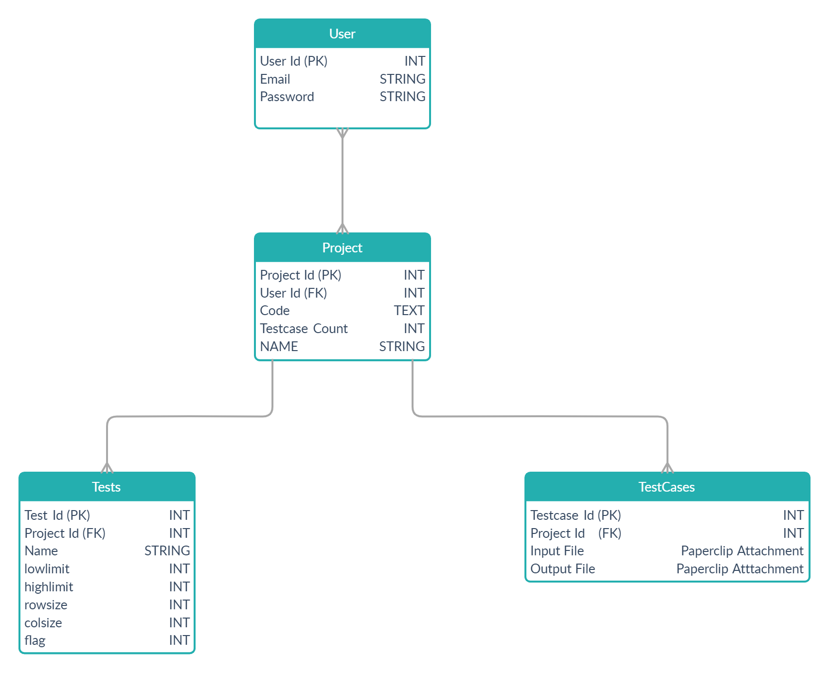

Figure-1: Database Schema Diagram

Figure-1: Database Schema

**ER Diagram:**

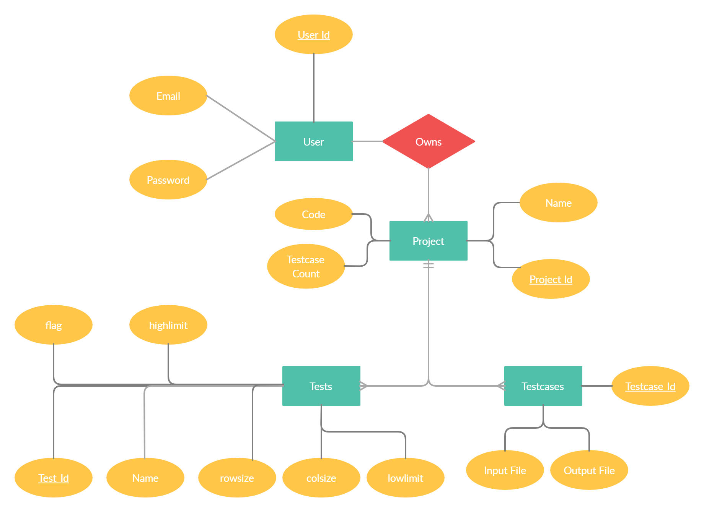

Figure-2: ER Diagram

**Flowchart:**

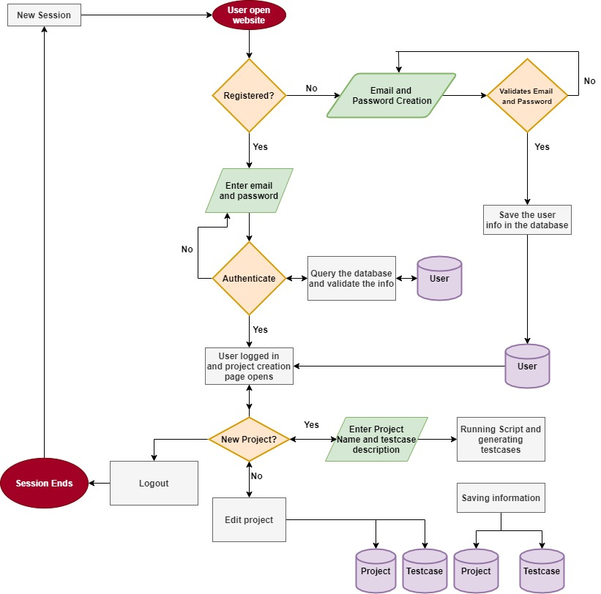

Figure-3: Flowchart

**Implementation Details:**

We used **Ruby on Rails** to build this project as the **MVC** architecture really helped us here.

**MVC** is a pattern for the architecture of a software application. It separates an application into the following components:

* **Models** for handling data and business logic
* **Controllers** for handling the user interface and application
* **Views** for handling graphical user interface objects and presentation

This separation results in user requests being processed as follows:

1. The browser (on the client) sends a request for a page to the controller on the server.
2. The controller retrieves the data it needs from the model in order to respond to the request.
3. The controller gives the retrieved data to the view.
4. The view is rendered and sent back to the client for the browser to display.

This process is illustrated in Figure below.

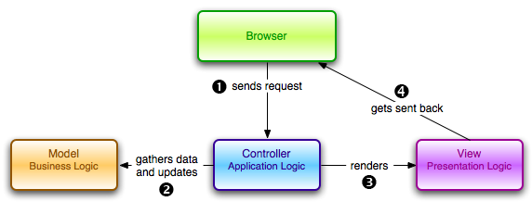

Figure-4: MVC Diagram

First of all, users need to pass through an authentication system to visit the website then they have option to retrieve or edit the older testcases they formed or to create a new problem.

We are putting up a form in front of users to ask for the testcase description , after they submit the form we run a RUBY script on our server to generate the outputs and then we are saving them on the database after that if users wants to get the outputs too then we are showing a prompt first to let the user give us the code on which he/she wants to run the testcases, after this we are sending an HTTP request to an API which generates and return the output file for each input file.

Apart from this we are also providing user with an Online IDE which they can use to play around with their code.

**For producing outputs, we used JDOODLE API:**

# What this service is?

JDoodle Compiler is an online API service to compile and execute Programs online via APIs, it supports Java, C/C++, PHP, Perl, Python, Ruby and many more languages.

# What type of API it is?

It is a JSON based Rest API.

# What are the Input Parameters for execute api call?

|  |  |
| --- | --- |
| Parameter | Description |
| clientId | Client ID for your subscription |
| clientSecret | Client Secret for your subscription |
| script | program to compile and execute |
| stdin | StdIn |
| language | language of the script (refer the supported language list below) |
| versionIndex | version of the language to be used (refere the supportoed languages and versions in list below) |

# What are the Output Parameters for execute api call when the execution is successful?

|  |  |
| --- | --- |
| Parameter | Description |
| output | Output of the program |
| statusCode | Status Code of the result |
| memory | Memory used by the program |
| cpuTime | CPU Time used by the program |

**For IDE on our project we used Sphere Engine JavaScript Widget:**

Sphere Engine Compilers module is a service that enables remote execution of computer programs and retrieving the results of their execution. It allows for:

* executing the source code of the program,
* specifying the input data for which we want to execute the program (optional)
* retrieving the execution results, including:
  + errors and warnings about the source code (e.g. compilation errors),
  + output data,
  + run-time errors,
  + execution time,
  + memory consumption.

**To Store Input and Output Files we used PaperClip Gem in Ruby:**

Paperclip is intended as an easy file attachment library for **ActiveRecord**. The intent behind it was to keep setup as easy as possible and to treat files as much like other attributes as possible. This means they aren't saved to their final locations on disk, nor are they deleted if set to nil, until **ActiveRecord::Base#save** is called.

Attached files are saved to the filesystem and referenced in the browser by an easily understandable specification, which has sensible and useful defaults.

**Input Types we are providing:**

* Integer
* Integer One Dimensional Array
* Integer Two Dimensional Array
* String
* String Array

We have written the generators in our **application_controller.rb** so that each of the function written here is accessible by all of the controllers, when user submits the form we read the inputs and call different type of function sequentially and generate the input files.

After that its onto users that whether they want to generate the outputs or not, if they don’t want to generate then they can simply download all the input files either separately or all together in a zip file.

If they want to generate the testcases then they can click on a button provided and after clicking the button we give a call to **jdoodle** api to generate the outputs and after getting the outputs we give users buttons to generate all the files either separately or all together in a zipped file.

**TESTING:**

We have written unit test to test each and every small features like (models, controllers) and after that we used integration test to test some business logics in the program.

**Some examples of testcases:**

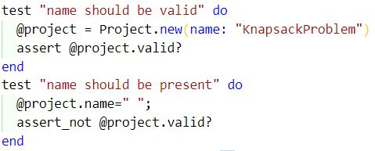

**Results**

As this is completely a Dev Based Project the main metric to measure that whether we have created something fruitful or not is by measuring **User Satisfaction.**

We have the project running on out local machine to measuring page load time, users count etc. is not feasible, our jdoodle call was synchronous so it takes a little extra time to generate the outputs but overall the project performed well..

**Screenshots:**

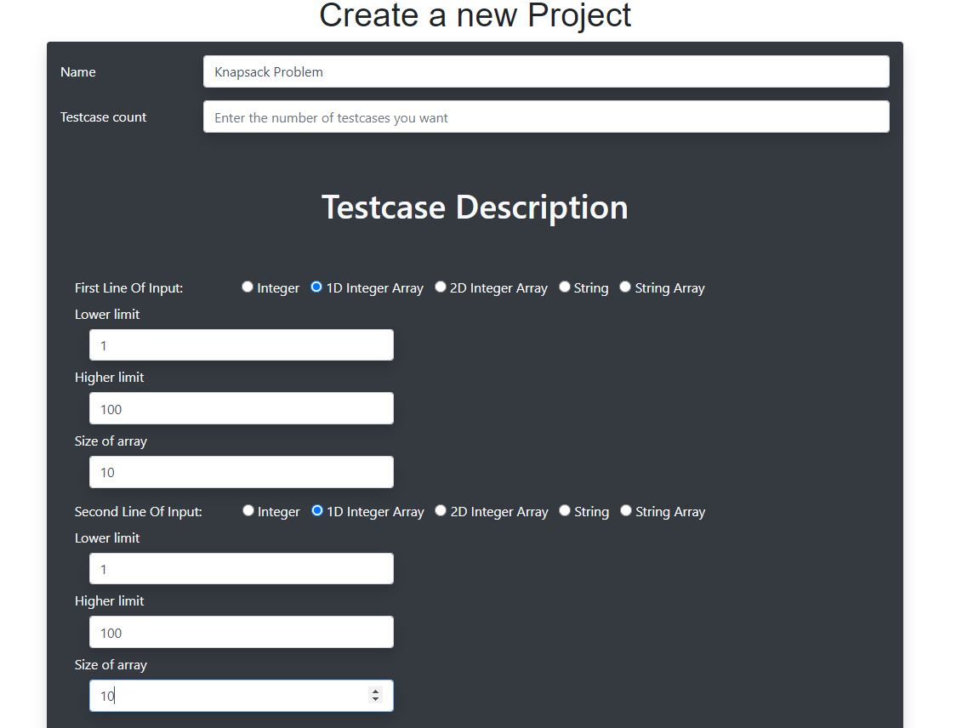

Figure 5: Testcase creation form

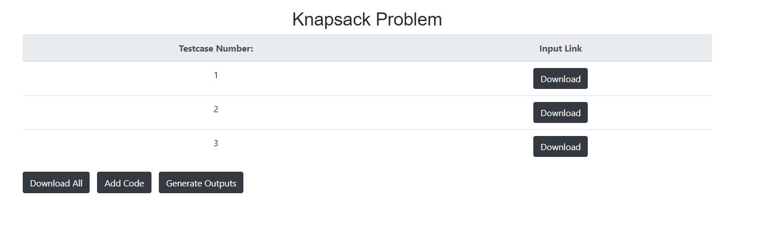

Figure 6: Problem Show Page

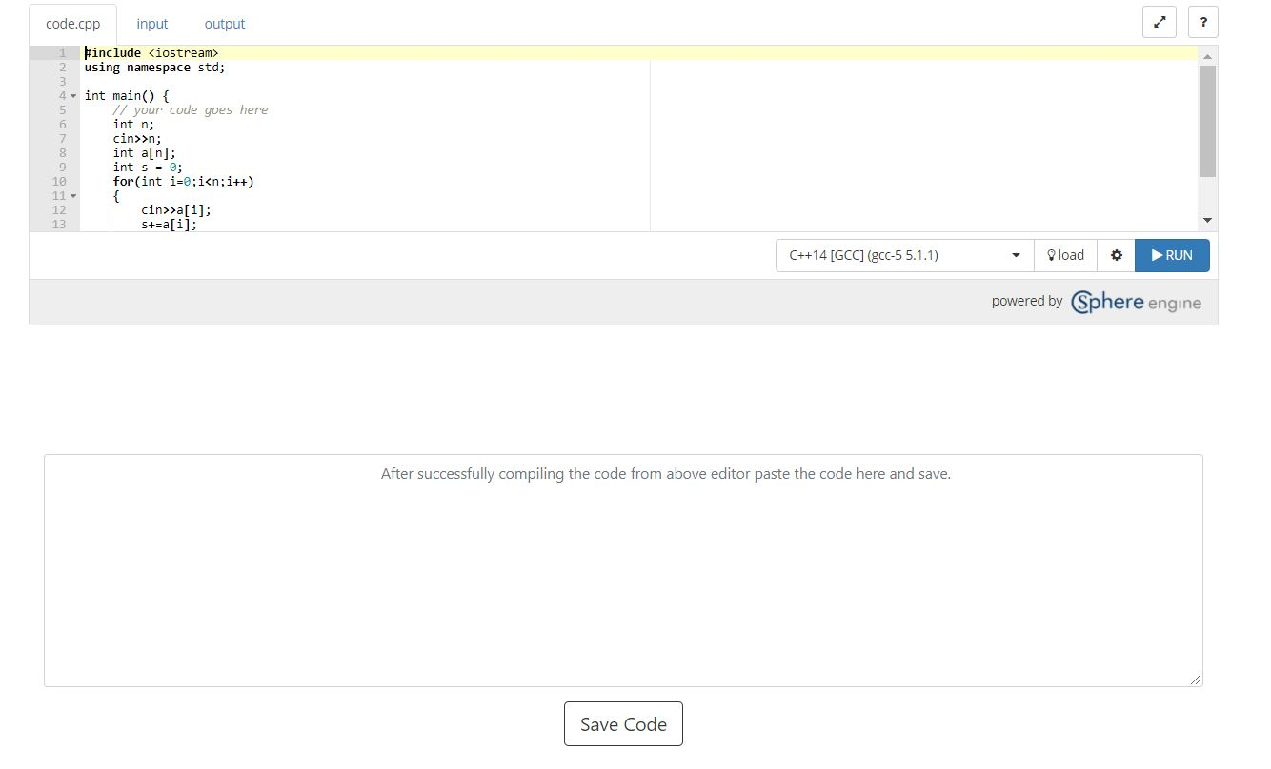

Figure 7: Code Submission Page

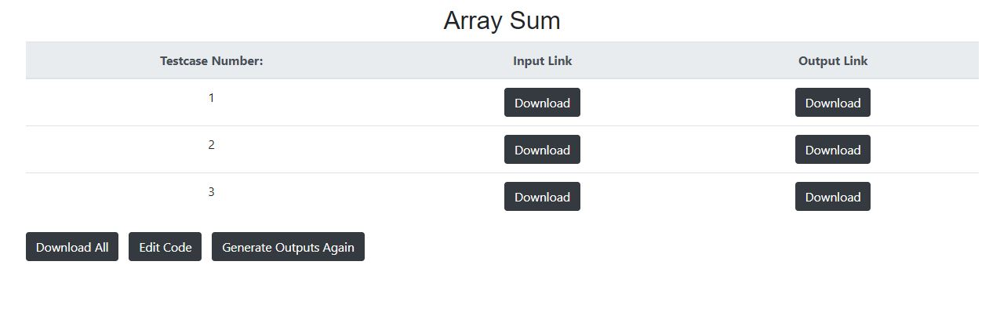

Figure 8: Project show page after generating outputs

**User Satisfaction Metrics:**

1. Testcase generation process must be quick.
2. Add enough options to modify testcases as much as user wants.
3. Jdoodle API to be working smoothly.

**Conclusions:**

We have successfully created the complete business logic for the problem statement mentioned.

The research papers we studied helped us in thinking of the different structures available to design our website.

Overall, we think this is an innovative idea as no such site exists which helps users in the way we are doing.

**Future Work:**

1. We were unable to find relevant papers for testcase generation of a graph, like a graph can take many forms like **Dense Graph, Bipartite Graph, Disconnected Graph etc.**
2. Choice of testcases can vary from user to user and no such research paper consider this parameter while constructing testcases.
3. If user uploads a pre written code on a website and requests for testcases for the code he uploaded. In this case we need to pass through a large number of iterations to get the result for the user. This factor is also missed in the research field.
4. Jdoodle Api call must be made asynchronous.
5. CI/CD Principles can be used to maintain the Devops Environment.

**References:**

|  |  |
| --- | --- |
| [1] | <https://www.researchgate.net/publication/321482764_Comparative_study_on_test_case_generation_a_survey> |
| [2] | <https://www.researchgate.net/publication/288645078_Automatic_software_test_case_generation_An_analytical_classification_framework> |
| [3] | <https://www.researchgate.net/publication/230868377_Content_Management_in_Ruby_on_Rails> |
| [4] | <https://www.researchgate.net/publication/228742449_New_technologies_for_web_development> |
| [5] | <https://www.researchgate.net/publication/339197695_A_Django_Based_Educational_Resource_Sharing_Website_Shreic> |
| [6] | <https://irejournals.com/formatedpaper/1701034.pdf> |
| [7] | <https://www.researchgate.net/publication/254008906_On_the_Analysis_of_Cascading_Style_Sheets> |
| [8] | <https://www.ijarse.com/images/fullpdf/1498735993_GOA_1005_ijarse.pdf> |
| [9] | <http://www.ijarcs.info/index.php/Ijarcs/article/view/3792> |
| [10 | <http://www.ijircce.com/upload/2018/april/67_A%20Review.pdf> |
| [11] | <https://core.ac.uk/download/pdf/230921159.pdf> |
| [12] | <https://ieeexplore.ieee.org/abstract/document/6106531> |
| [13] | <https://ieeexplore.ieee.org/abstract/document/5410700/> |
| [14] | <https://ieeexplore.ieee.org/abstract/document/6120863> |
| [15] | <http://worldcomp-proceedings.com/proc/p2016/ICW3865.pdf> |
| [16] | R. Blanco, J.Tuya and B. Adenso-Díaz, “Automated test data generation using scatter-search approach”, Information and Software technology, vol. 51, Issue 4, **(2009)**, pp. 708-720 |
| [17] | B. N. Biswal, S. S. Bar panda and D. P. Mohapatra,  International Journal of ComputerApplications, vol. 1, Issue 14, **(2010)**. |
| [18] | Kuhlman, D. (2011). A Python Book: Beginning Python, Advanced Python, and Python Exercises. Platypus Global Media |
| [19] | Holovaty, A., & Kaplan-Moss, J. (2008). The Definitive Guide to Django: Web development done right. Après. |
| [20] | <https://docs.python.org/3/tutorial/index.html> |
| [21] | <https://www.w3schools.com/TAGS/default.ASP> |
| [22] | <https://www.oreilly.com/library/view/the-ruby-programming/9780596516178/> |
| [23] | <https://selenium-python.readthedocs.io/> |
| [24] | <https://www.w3schools.com/css/> |
| [25] | <https://rubyonrails.org/> |
| [26] | <https://www.javascript.com/> |
| [27] | <https://docs.djangoproject.com/en/3.1/> |
| [28] | https://ieeexplore.ieee.org/document/4345005 |
| [29] | https://link.springer.com/article/10.1007/s10009-008-0086-x |
| [30] | https://www.researchgate.net/publication/261079289_A_performance_comparison_of_SQL_and_NoSQL_databases |
| [31] | https://dl.acm.org/doi/10.1145/1809028.1806598 |
| [32] | https://dl.acm.org/citation.cfm?id=175243 |
| [33] | https://ieeexplore.ieee.org/document/7742298 |
| [34] | https://www.researchgate.net/publication/318816158_An_Introduction_to_Docker_and_Analysis_of_its_Performance |
| [35] | https://www.researchgate.net/publication/292542090_Agile_Software_Development_Methods_Review_and_Analysis |
| [36] | https://ieeexplore.ieee.org/document/947100 |
| [37] | https://www.sciencedirect.com/science/article/pii/S0164121212000532 |
| [38] | https://link.springer.com/chapter/10.1007/978-1-4471-0947-1_11 |
| [39] | https://ieeexplore.ieee.org/abstract/document/4375251 |
| [40] | https://www.sciencedirect.com/science/article/pii/S0167642314005735 |
| [41] | https://www.researchgate.net/publication/330656300_A_new_model_for_the_selection_of_web_development_frameworks_application_to_PHP_frameworks |
| [42] | https://www.researchgate.net/publication/221463561_A_comparison_model_for_agile_web_frameworks |